GOVERNMENT COLLEGE OF NURSING, GSVM CAMPUS, KANPUR

REPORT ON BLOOD DONATION DAY CAMP - 2023

The World blood donation day is observed every year on 14th June. The event was organised for the first time in 2004, by four core international organizations: the World Health Organization, the International Federation of Red Cross and Red Crescent Societies; the International Federation of Blood Donor Organizations (IFBDO) and the International Society of Blood Transfusion (ISBT) to raise awareness of the need for safe blood and blood products, and to thank blood donors for their voluntary, life-saving gifts of blood.
On the date 14th June 2023, blood donation camp is organized by College of Nursing, Kanpur with collaboration of LLR and Associated Hospital, Kanpur. Blood donation camp was inaugurated by Dr. R K Singh, Superintendent In Chief of LLR Hospital. The camp was visited by Dr. Lubina Khan (HOD Blood Bank) and appreciated to the students Volunteers for Blood donation. Lt. Col Dr. Karesh Prasad, Principal, Prof. Naveena JH, Vice Principal has the great contribution in the success of the programme. Faculty, Mrs. Ranjna Singh Rajpoot, Assistant Professor and Mrs. Nisha, Mrs. Meenakshi and Ms Anjali, Nursing Tutor, College of Nursing, Kanpur were the organizing team members of the Blood Donation Camp. Donation of blood is very critical and crucial for saving lives many patients and those who have met with accidents. It is as such a great service or contribution to the society and people living in it.
The theme of the event was “Give Blood, Give Plasma, Share Life, Share often”. The Blood Donation camp started at 9.00 AM overwhelmed with great passion and social affinity brave young generation donated their valuable blood with much enthusiasm. After that, all the nursing student especially the B.Sc. Nursing III Semester, participated in the program by donating blood in a very positive way. Some students of B.Sc. Nursing 4th Year did their blood donations by becoming a part of this program. Apart from nursing students, 2 Doctors were also donated blood in the camp. Approximately 26 students from our college were registered but because of unfit in Blood donor criteria, 10 nursing student has been donated the blood. Nursing student of B.Sc. Nursing III Semester has started the camp by donating the blood. The blood donation process was done by the medical team of LLR Hospital. Approximately 12 Unit Blood has been donated in the camp. The program lasted till 1 pm in the afternoon. The camp witnessed a huge success with active participation from students and faculties of College of Nursing, Kanpur.

PROGRAMME OVERVIEW -
Activity/Event | Programme Schedule
Name of event | Blood Donation Camp
Date of event | 14-06-2023
Organized by | College of Nursing Kanpur
Conveyors | Lt. Col Dr. Karesh Prasad, Principal  Prof. Naveena JH, Vice principal
Organizing Team | Mrs. Ranjna Singh Rajpoot (Assistant Professor)  Mrs. Nisha Yadav (Nursing Tutor)  Mrs. Meenakshi Singh (Nursing Tutor)  Ms. Anjali (Nursing Tutor)
Name of the Association | In collaboration with LLR Hospital, Kanpur
Venue | Blood Bank, LLR Hospital, Kanpur
Type of activity/Event | Blood Donation
Activity/Event objectives | 1. To collect blood units but also to make students aware about blood and its benefits.  2. To motivate students to come forward and donate for this noble cause.  3. To encourage nursing students so that once the initial hesitation/ fear goes away, the donor will look forward to such camps in near future too.  4. To help anyone, in case of any requirement for blood.
Participation | Nursing Student’s Registered – 26  No. of Nursing Students Donated Blood -10  No. of Doctors Donated Blood – 02
No. of Unit Blood donated | 12
Enclosures | - Report  - Photos
GLIMPSE OF THE EVENT

GLMPSE OF THE PROGRAMM
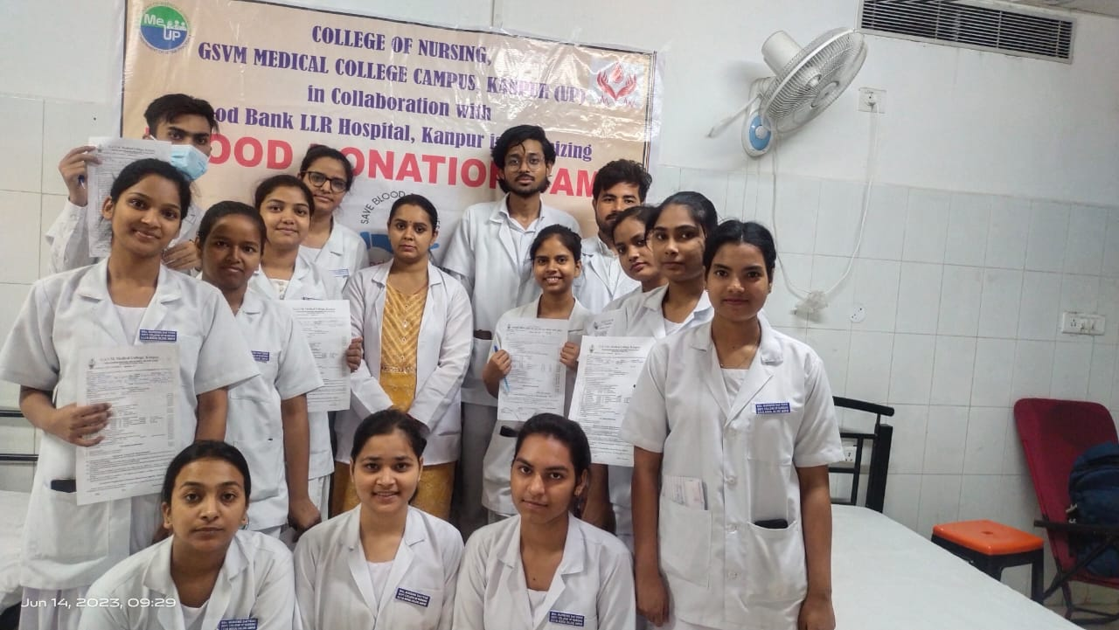
Student Volunteers Undergoing Registration Process for Blood Donation in the Camp

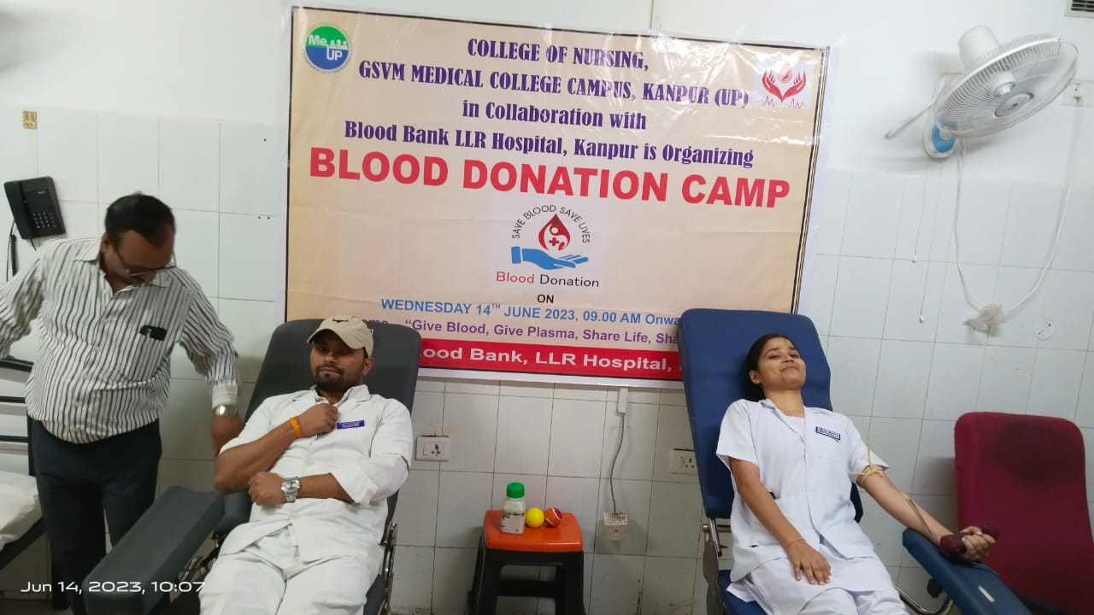
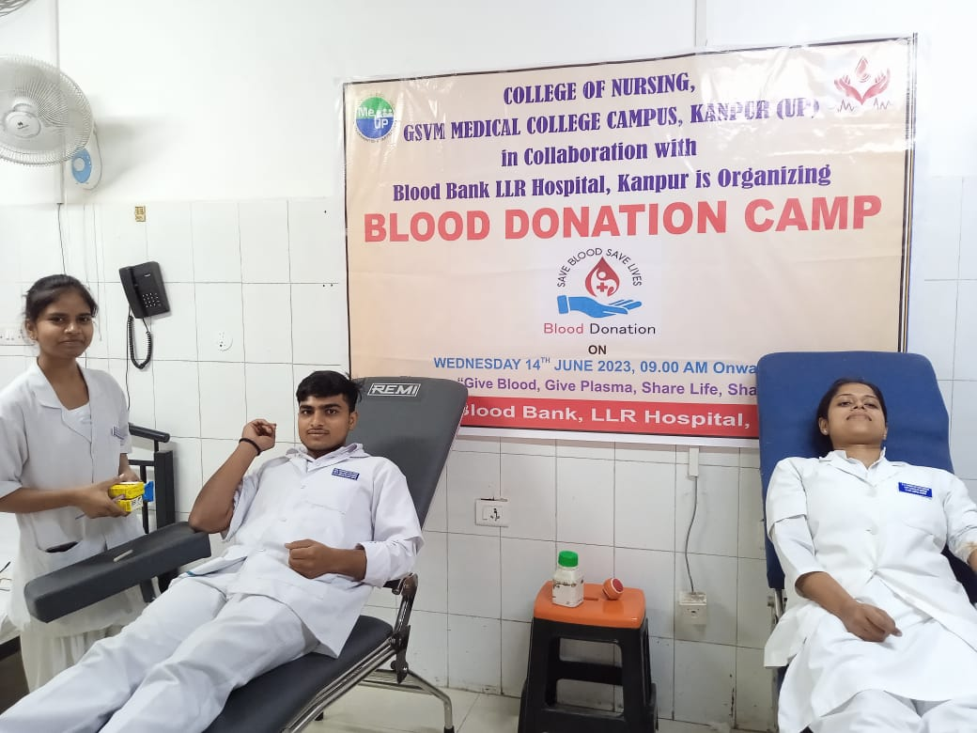
Student Volunteers Donating Blood in the Blood Donation Camp

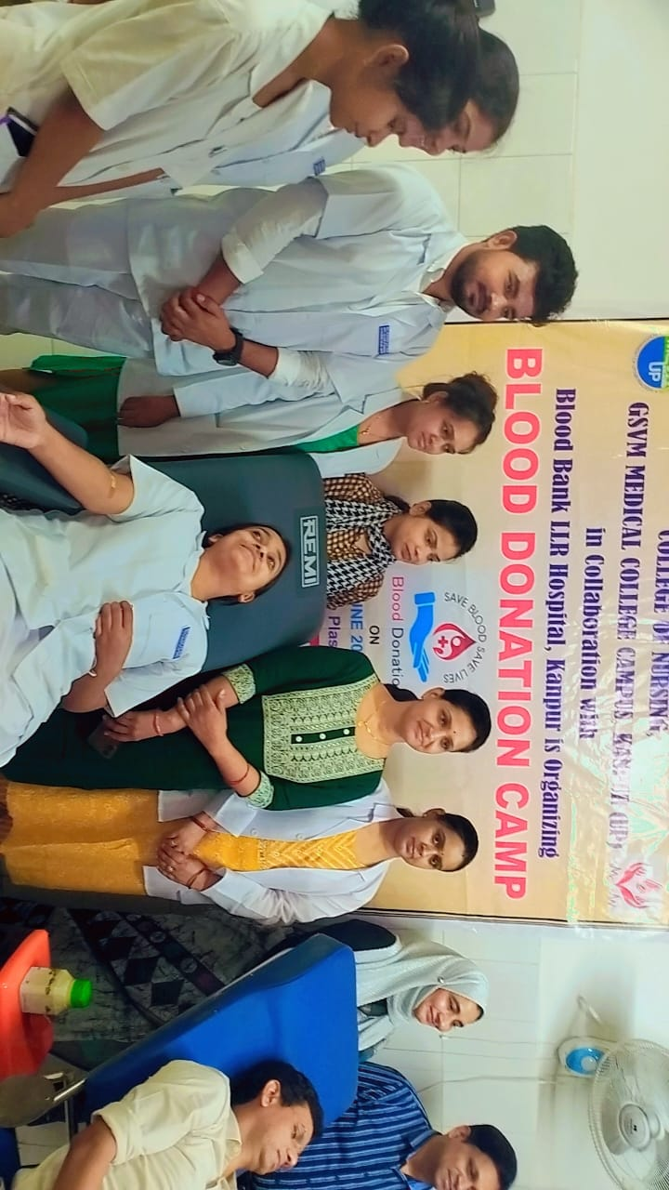
Dr. Lubina Khan, Nodal Officer of Transfusion Medicine Department, Medical College, Kanpur, Faculty College of Nursing, Kanpur and Student Volunteers in Blood Donation Camp
